



Presents

little VOICES

www.pequenasvoces.com

Supported by the following funds
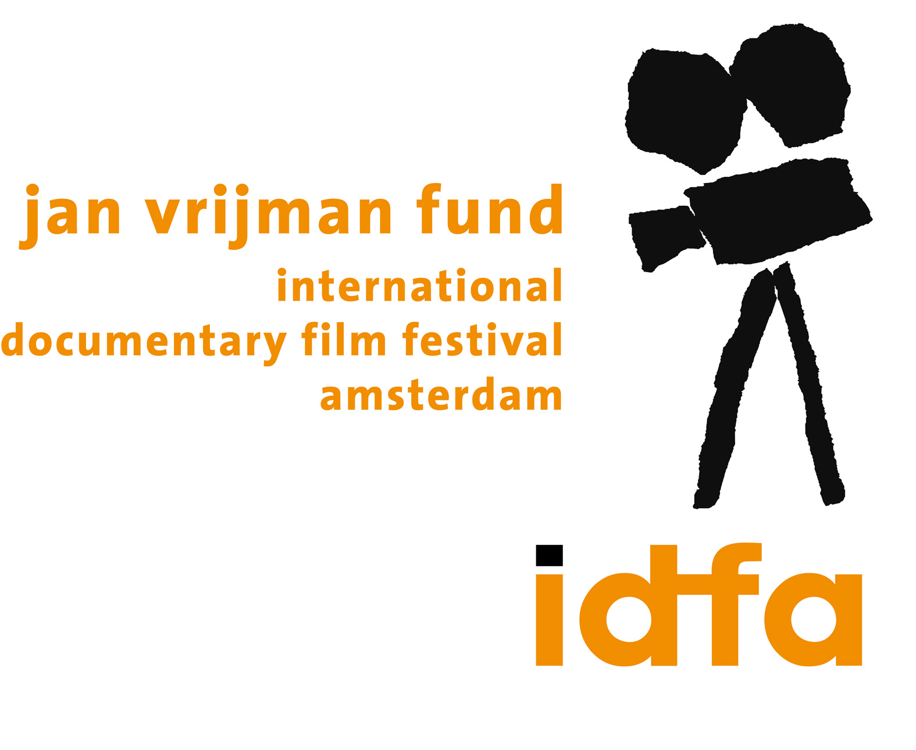

CREW LIST

Production Company:

A film by:

Direction:

Executive Producer:

Script:

Director Assistant:

Character and conceptual Design:

Art Director:

2D Character Animation:

Film Editing:

3D Animation:

Music:

Sound design:

Associate Producer:

Original drawings:

e-NNOVVA / RCN Cine,
CAHUPEDILLO CINE, JAGUAR TALLER DIGITAL S.A.

JAIRO EDUARDO CARRILLO

JAIRO EDUARDO CARRILLO
OSCAR ANDRADE

JAIRO EDUARDO CARRILLO
OSCAR ANDRADE
HAROLD TROMPETERO
JULIAN GIRALDO

JAIRO CARRILLO
OSCAR ANDRADE

DANIEL CAMILO GOMEZ

KAROLINA VILLARRAGA

ADELA MANOTAS

MANUEL D´MACEDO
DAVID CORREA

JUAN FELIPE OROZCO
CARLOS ESTEBAN OROZCO
DANIEL CAMILO GOMEZ
RICARDO GARCIA

MIGUEL ANGEL RINCON
ANDRÉS ROMERO LINA RAMÍREZ JIMMY MEDINA
CAMILO GUTIÉRREZ
GERMÁN PIÑEROS

SONGO STUDIO
SONGO STUDIO

FRANCISCO HUERFANO
CAROLINA SALAZAR

MADE BY DISPLACED CHILDREN BY THE COLOMBIAN WAR.

NARRATIVE SYNOPSIS
“little VOICES” is animated documentary in 35 mm (75 minutes of duration)
LOGLINE
“little VOICES” is an animated documentary about 4 peasant children who were displaced by the drugs war in Colombia and how they dealt with this situation.

SYNOPSYS
“little VOICES” is an animated documentary based on interviews and drawings of a new generation of displaced children (8 to 13 years old) who have grown up in the middle of violence and chaos in Colombia. The interviews show how they perceive their reality. The stories have been illustrated and animated based on the original drawings of the children.
LINEAL NARRATION:
The voice of the documentary is a choral voice in which first the children tell their experiences of the country side, second they will speak about the armed conflict and why they were displaced to Bogotá, third they will tell about their arrival to Bogotá and how they confront a cold and indifferent city and finally we finish in how the love of their family is the only thing that gives them hope to continue.
Aesthetic:
The animation of this documentary is based on the original children’s drawings made during workshops throughout the year, those drawings will then be digitized and animated by computer.
THE NARRATION:
Even though the interviews are from different parts of Colombia, the film will develop a common space where they get together such as the town, the country side, soccer field, etc. The children will inhabit one communal neighborhood in Bogota.
2) The children don’t interact directly on the stories of other children, but they will participate in communal activities for example, they will go to the same school, town or fair, they can play together, swim in the same river or attend the same church.
Each child’s story has a specific symbol which is going to appear in all the different stories again and again for example a jeep in which they were displace, the hat, the cat, the dogs etc.
CHARACTERS:
The story is told by four children who were displaced to Bogota, the capital city of Colombia, by different circumstances:
Juanito: 12 years old
Jhoncito: 11 years old
Lulu: 9 year old.
and Pepito: 9 years old
INTENTION
After I finished the short film “little voices”, I realized that in order to understand the war in Colombia, we cannot just hear the victims of the conflict but also the children who collaborate in this war. We have to hear children who have become guerrilla fighters or paramilitary fighters to understand that they choose this path because society doesn’t offer any other options.
I feel very strongly about giving these voices of the children a loud speaker because we don’t listen to them very often.
After hearing again and again these interviews, I realized that in this war, There is no such thing as “good” or “winners” and that we all lose as a result. Also, we have to blame ourselves because we feed this war with silence and indifference.
My hope is that we understand that we are never going to end this war with more arms, rifles, missiles or bullets, but with more housing, health, education and the resultant hope this provides for future generations.
“ Little voices” the short film based for the feature film I am making has been shown in more than 40 International film festivals such as, the Venice film festival new territories 2003, Havana film festival and Rotterdam film festival. www.locombia.net/voices
Global Relevance
According to IDMC (Internal displacement monitoring center)
“At the end of 2009 there were up to 4.9 million *IDPs in Colombia, bringing it alongside Sudan as one of the two largest internal displacement situations in the world.”
In comparison, the population of Italian citizens displaced by war would be as follows:
Milano | Italy | 1,307,495
Napoli | Italy | 962,940
Torino | Italy | 909,583
Palermo | Italy | 656,081
Genova | Italy | 609,746
Bologna | Italy | 377,220
TOTAL |  | 4,823,065

In comparison, the population of European citizens displaced by war would be as follows:
Amsterdam | Netherlands | 729,000
Frankfurt | Germany | 644,000
Helsinki | Finland | 549,000
Oslo | Norway | 505,000
Dublin | Ireland | 482,000
Lyon | France | 415,000
Zürich | Switzerland | 337,000
Valladolid | Spain | 317,000
Lisboa (Lisbon) | Portugal | 563,000
TOTAL |  | 4,541,000

*IDP Internally displaced persons
*http://www.internal-displacement.org/8025708F004BE3B1/(httpInfoFiles)/18EFD5E90A66EA75C1257725006524C1/$file/GO2009_Colombia.pdf

DIRECTOR’S BIOGRAPHY
Jairo Eduardo carrillo

He is a full time lecturer at Universidad de los Andes in the department of design in Colombia where
he teach animation and is a director of a line of research in visual products.
Was a lecturer for 6 years in different universities in England.
He realized several digital interactive animation projects, among which "3d music" with the London symphonic orchestra. Newspapers in England as well as the New York Times qualified this work as “a fortunate hybrid between a fantasy video game and a fantasy Disney movie. Link of the article NY times
http://www.nytimes.com/2002/10/14/arts/design/14ARTS.html

In film he Co-direct “God brings together and they fall apart" 240.000 spectadors and 40 copies across Colombia And “Muertos de miedo” with 480.000 spectators and 70 copies across Colombia.
He also direct his first short film called also “little voices” which was premiere in Venice film festival in new territories 2003 and won 8 international prices.

Oscar Andrade

Oscar Andrade is a Film & TV producer graduated at the National University of Colombia, 1992. His experience with drawing and videogame programming lead him to create digital animations at the end of his studies. Oscar took drawing, acting and caricature courses independently. He worked as video designer, animator and multimedia programmer until year 2001, when he founded Jaguar Digital Workshop, a company that produces contents for animation & videogames. Its most remarkable works are the animation series "Flotanautas" and the film feature "Born under fire" Co-directed with Jairo Eduardo Carrillo, project winner of Proimagenes' National Film Fund. He has been teaching for 12 years at the University of Los Andes and the National University at Bogotá, where he has mentored honoured thesis. As a jury, he has participated in the FDC National Film Fund in the category of Short films, amongst other 5 national contests. Oscar is the founder and director of LOOP, the latinamerican animation & videogames festival, pioneer in its field in the region since 2003.

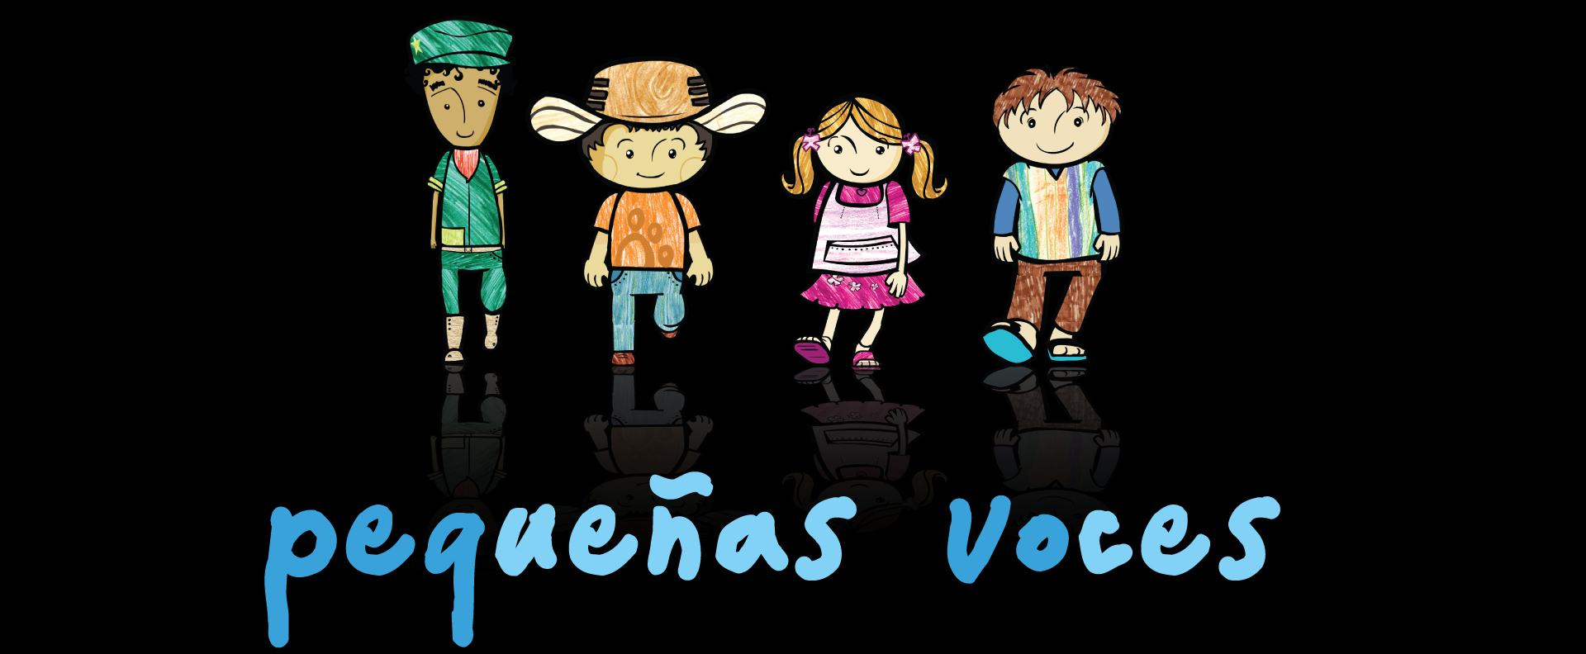
“If we listen to the children we would silence the sound of bullets”
The Colombian human rights commission.

